MAP TABLE PAGES

The Map table section includes the following 4 pages and a Topographic Map:

- Elevation Profiles
  - Elevation Profile – Straight Line from Barker Park, to the top of Ben Lomond Peak
  - Elevation Profile - North Ogden Pass, on the established trail, to Lewis Peak
  - Elevation Profile – Straight Line from Barker Park, to the top of Chilly Peak
- Elevation Profiles
  - Elevation Profile - North Ogden Pass, on the established trail, to Ben Lomond Peak
- Handling Declination, 3 Methods
- How to Orient this Map and Finding Your Location

The main map that is mounted in the Map Table is a USGS 7.5 Series Topographic Map, North Ogden Quadrangle, Utah. The map is printed on all weather paper and was purchased from the Utah Idaho Map Store. A replacement map can also be ordered from the USGS Store.

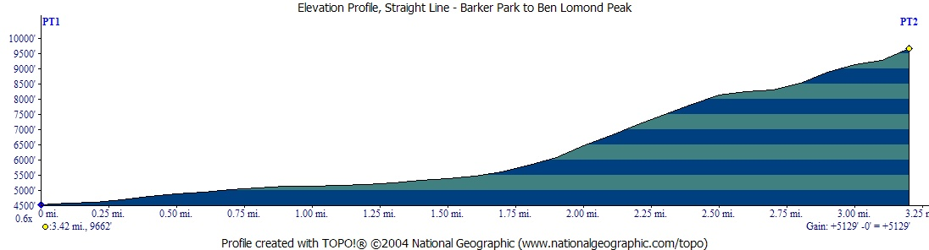
If you were to hike, in a straight line from Barker Park, where you are standing, to the top of Ben Lomond Peak (not a suggested route):
Starting Elevation: 4533 Ft
Ending Elevation: 9662 Ft
Elevation Change: 5129 Ft
Total Miles (round trip): 3.42 x 2 = 6.84 Miles

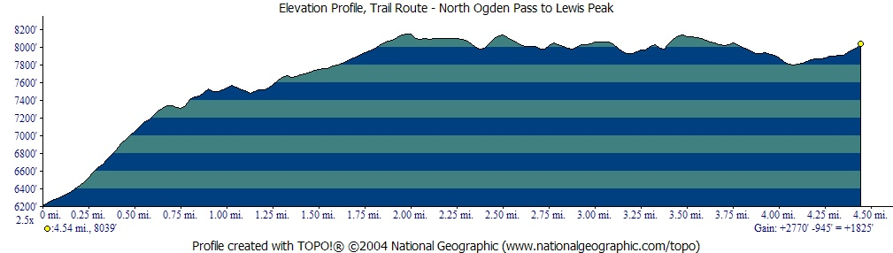

If you were to hike from North Ogden Pass, on the established trail, to Lewis Peak:
Starting Elevation: 6214 Ft
Ending Elevation: 8039 Ft
Elevation Change: 1825 Ft
Total Miles (round trip): 4.54 x 2 = 9.08 Miles

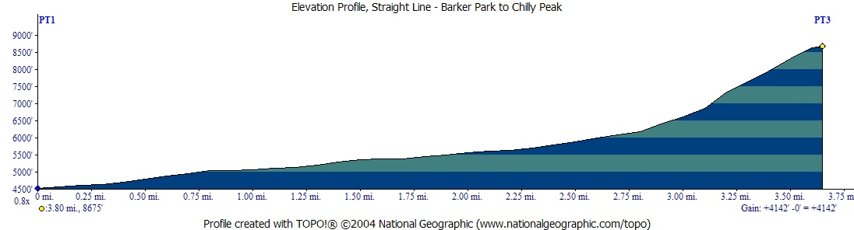

If you were to hike, in a straight line from Barker Park, where you are standing, to the top of Chilly Peak (not a suggested route):
Starting Elevation: 4533 Ft
Ending Elevation: 8675 Ft
Elevation Change: 4142 Ft
Total Miles (round trip): 3.80 x 2 = 7.60 Miles

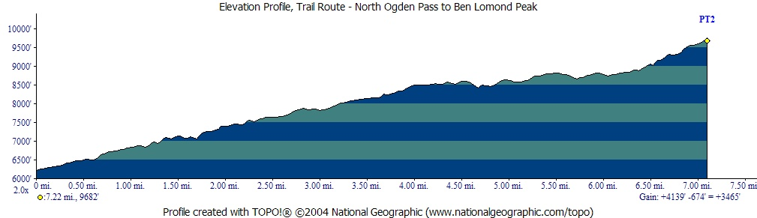
If you were to hike from North Ogden Pass, on the established trail, to Ben Lomond Peak:
Starting Elevation: 6217 Ft
Ending Elevation: 9682 Ft
Elevation Change: 3465 Ft
Total Miles (round trip): 7.22 x 2 = 14.44 Miles

If you were to hike from North Ogden Pass, on the established trail, to Lewis Peak:
Starting Elevation: 6214 Ft
Ending Elevation: 8039 Ft
Elevation Change: 1825 Ft
Total Miles (round trip): 4.54 x 2 = 9.08 Miles
Handling Declination, 3 Methods*

Understanding declination can be frustrating to some people, don’t get discouraged. Use one of the following methods and you will begin to understand the topic with time and experience.

- Map Marking
Using this method all bearings are based on Magnetic North, no adding or subtracting of numbers is needed. This can be done by locating the declination symbol on your map; placing a ruler edge on the declination line, drawing an extension of the line from the top to the bottom of the map, from this line draw parallel lines a ruler width apart across the entire map. When taking a bearing the side of the compass base plate is aligned with the newly drawn lines. This will be the method used to illustrate map orientation on this table.

- Compass Marking
Locate the tic mark on the compass housing that represents the declination of the area where you live. For Pleasant View it is 14 degrees east. With a permanent marker draw a line from the tic mark to the center of the compass, reference figure 1. The usual procedure when taking a bearing in the field is to line up the compass needle with the orienteering arrow. With this method the new line becomes the orienteering arrow. The compass needle is lined up with the new mark. The compass base plate is aligned with the North-South markings of the map, so no marking of the map is required. This has the effect of making all compass bearings based on true north.

If you use the compass in another part of the country where the declination is different the line on the compass housing will have to be rubbed off and a new line drawn.

- Adjustable Compass
Some compasses have a feature where the declination can be set. All you do is turn the adjustment screw on the compass and all readings are automatically converted to true north. This is the easiest method, if you can find this type of compass.

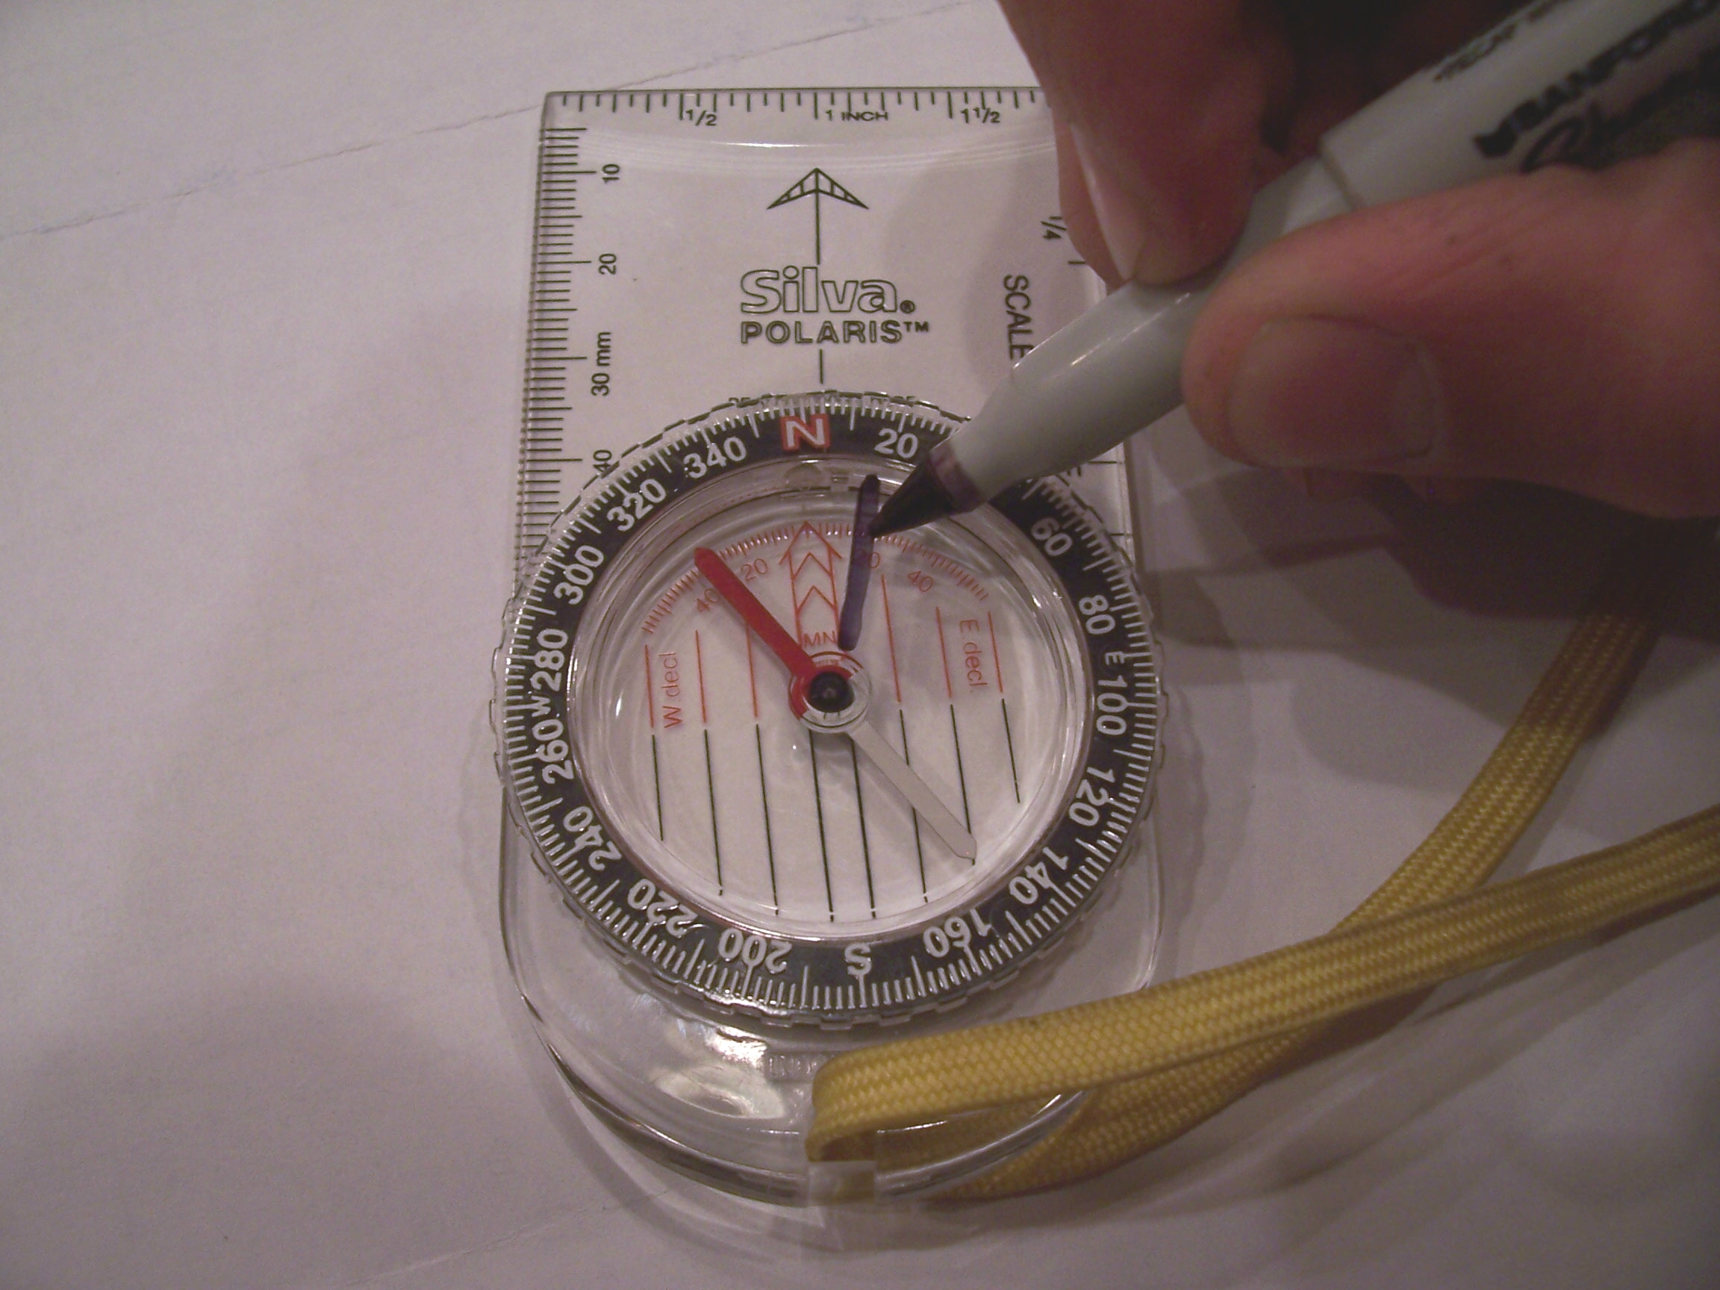
* Information here has been paraphrased from an article written by Ron Watters, Director Idaho State University Outdoor Program, 1996 (www.isu.edu/outdoor/maplong.htm)

Figure 1. Method 2, Compass Marking @ 14 degrees East
How to Use this Map

Orienting the Map (Method 1)

Rotate the compass housing until N (360 degrees), and the orienteering arrow is lined up with the direction of travel arrow on the compass base. Place the compass on the map and lay the edge of the compass along side any of the magnetic north lines drawn on the map (declination lines, Method 1). Rotate the map (table) until the compass needle is directly over the orienteering arrow on the compass housing. The map is now oriented to your surroundings.

Finding your Location

Look around you and pick out two features that you recognize, a good choice would be Ben Lomond Peak and Chilly Peak, they are very prominent features. Point the direction arrow of your compass toward the top of Ben Lomond Peak, rotate the compass housing until the orientation arrow and the compass needle are aligned. Now lay your compass on the map with one edge of the base plate touching Ben Lomond Peak. Keeping an edge on the peak, rotate the compass around the peak until the meridian lines in the compass housing (lines parallel to the orienteering arrow) are lined up with the magnetic north lines that are drawn on the map. Visualize a line along the edge of the compass, the line should pass very close to the your location at Barker Park. If you had your own map you could draw a line on the map.

Repeat the same exercise with the compass pointing at Chilly Peak. If you lined up the compass correctly an imaginary line drawn along the edge of the compass would intersect with the first line at your location, in this case Barker Park. Again, if you had your own map you could draw a line, where the two lines intersect would be your location. Knowing your location and possessing some basic compass skills, you could navigate yourself in any direction to any location on the map.

Pace Line
A pace is defined as two steps. Perhaps it will be easier to remember if you think of a pace as every time your right foot hits the ground. With both feet together, step with the left foot, then right foot, this is one pace. As you walk at your normal walking stride, each time your right foot hits the ground add one to your pace count. Determine your pace for 100 feet by stepping off from 0 to 100 feet using the Pace Line.

Three Point Course
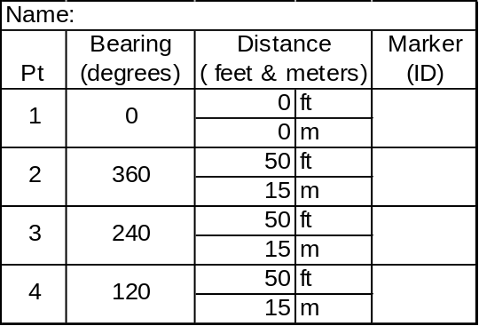How to Set a Bearing and Reach a Destination
Hold your compass in front of you with your direction-of-travel arrow pointing straight ahead. Turn the compass dial to the bearing (degrees) listed on the route template (for ease-or-use no correction for declination is required on this course). Turn your entire body until the compass needle covers (lines up with) the orienteering arrow on the floor of the compass housing (the north end of the needle should be pointing toward North on the housing). Pick a landscape feature, rock, tree, or something else in line with the direction-of-travel arrow and walk to it. When you get to the feature check your compass bearing and head toward another object further along your route. Repeat, walking from point to point until you arrive at your destination, in this case, a brass marker with a number or letter on in. Write down the Marker ID.

